|  |  |
| --- | --- |
|  |  |
| Day Care Project |  |
|  |  |
|  | CSYE-6000Object Oriented Design |
|  | Team:  * Maharshi Jinandra * Shreya Kichloo * Hamad Alsuhaibani |

**Content**

1. Problem Statement
2. Proposed Solution
   * 1. Object Model Diagram
     2. Design Solution
3. Future Scope Implementation
4. Snapshots

**Problem Statement**

A Daycare model is to be created which captures the following defined deliverables:

* Student Enrollment: Attributes like Student name, age, Parent’s name, address, phone
* Tracking of annual registration renewal
* Tracking of immunization anniversaries.
* Assignment of students to teachers according to the state regulations
* Assignment of student/teacher groups to classrooms according to state regulations.
* Meeting all the minimum requirements
* Using of Design Patterns:
  + - Factory Design Pattern
    - Model View Controller Design Pattern
* Alerts for upcoming/overdue dates
  + - Annual employee review
    - Annual registration from original walk-in-date
    - Track student immunization records
* Objects from CSV or use of Database (SQL){optional}
  + - Students
    - Teachers
    - Daycare Ratio Rules
      * 1. Student to Teacher
        2. Groups to Classroom
    - Immunization Rules
    - Each Student’s Immunization Record

**Proposed Solution**

**Object Model Diagram**

**Design Solution**

The solution that we have approached for implementation of the Daycare system includes the following:

* Eclipse IDE
* Java
* PostgreSQL 10.16
* Spring boot framework
* Hibernate Framework
* Html, CSS, Bootstrap
* Spring boot Scheduler for Emails

The approach that we came up with was using a Spring boot framework which provided an Object Relational Mapping between the objects and attributes of the student, teacher, classroom classes in database. The database which has been used in the project is PostgreSQL. Hibernate is the ORM framework that has been implemented in the Daycare design which provides not only the Factory Design pattern but also Domain model pattern, Proxy design pattern, Query Design pattern and Data Mapper Pattern. The entity class(@Entity) annotation maps the objects attributes to the database which helps in perform the reading operation within. The tables inside the database are created using @OnetoMany annotation for providing tables interlinkage. The controller class is used to perform the operation on the database and @RequestMapping is used to return the html pages created using CSS and bootstrap for rendering the UI on the server.

The model control view design is achieved by using Thymeleaf which is basically is HTML template engine. The bootstrap is used for providing design and styling of the UI screens.

The alerts for the upcoming vaccinations anniversaries and student and teacher’s registration and enrollment anniversaries are handled using simple mailing scheduling service. The JavaMailSender Interface is utilized for sending mails. The configurations are set inside the EmailConfiguration.java class and the dependencies are provided in the pom.xml. The @Service annotation is used which makes the component scanning mechanism of spring analyze that the business logic for mailing implementation is provided inside that specified class file.

UserService is created for a single level system login entry which will have access to all the facilities that the daycare center provides. The multiple roles login can be created for the future implementation.

**Future Scope Implementation**

In today’s world the emerging need for importance of providing early education for a child and to provide a good childcare is resulting in high need for Childcare facilities.

The design which we have created is a single level implementation for a Childcare facility. The design can be enhanced by creating a whole ecosystem for such facility which involves interactions on multiple enterprise, network, and organization levels.

Current solution implements and provides login capabilities for a system user, but the future implementation could include the following:

* Providing Parental sign in and login access.
* Giving role base access to teachers and other working staff.
* Creating multiple roles like non-staff members and providing access to them for their respective workspace.
* Implementation of the Enquiry request workflow.
* Implementation of budgetary system for calculation of profits and loss.
* Based on the budgetary system implementation of new hiring modules, expansion modules etc.
* Implementation of a ranking system for providing information regarding effectiveness among others similar facilities.
* Including a CRM module to keep track of business-related workflows.
* Implementing GPS utilities to keep track of students and sending updates/notifications to the respective guardians.
* Creating mobile based application version.

**Snapshots**

**UI Design**

Home Screen

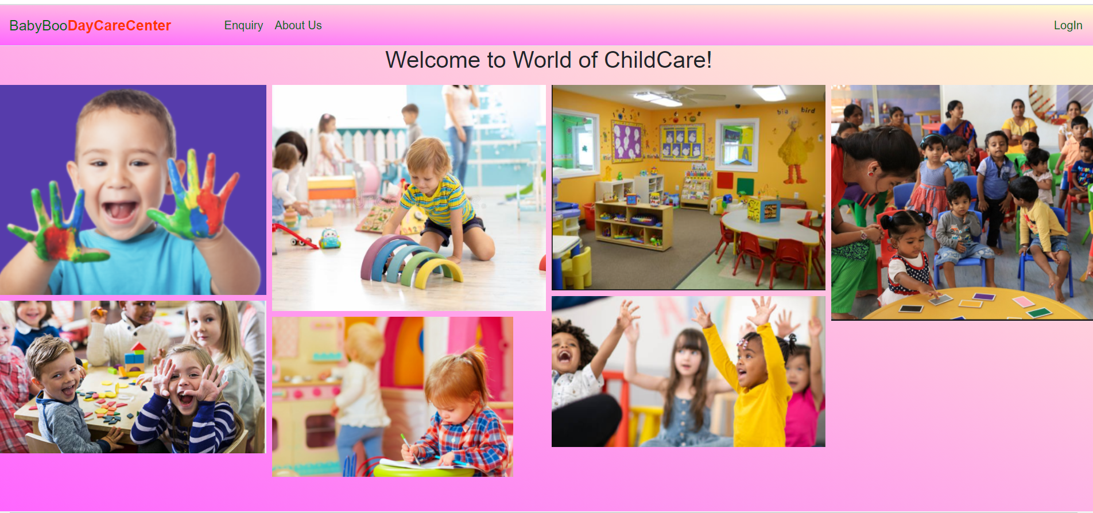

Enquiry Screen

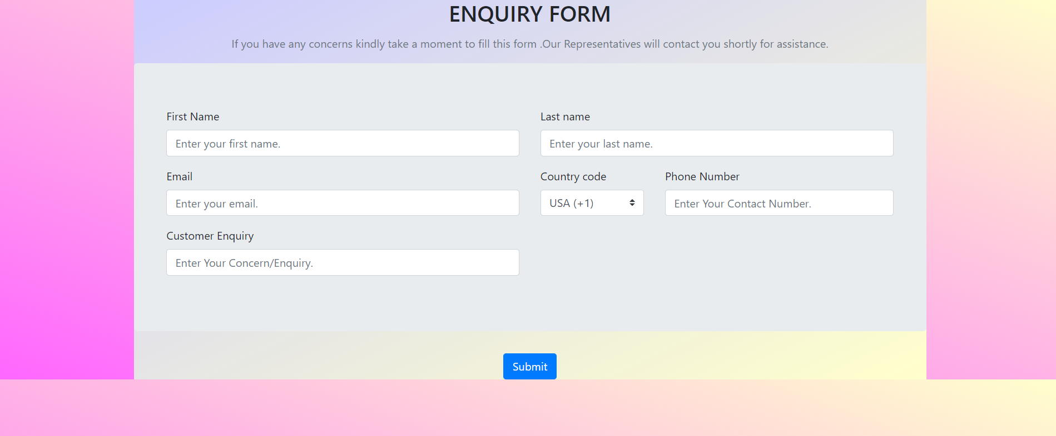

About Us Screen

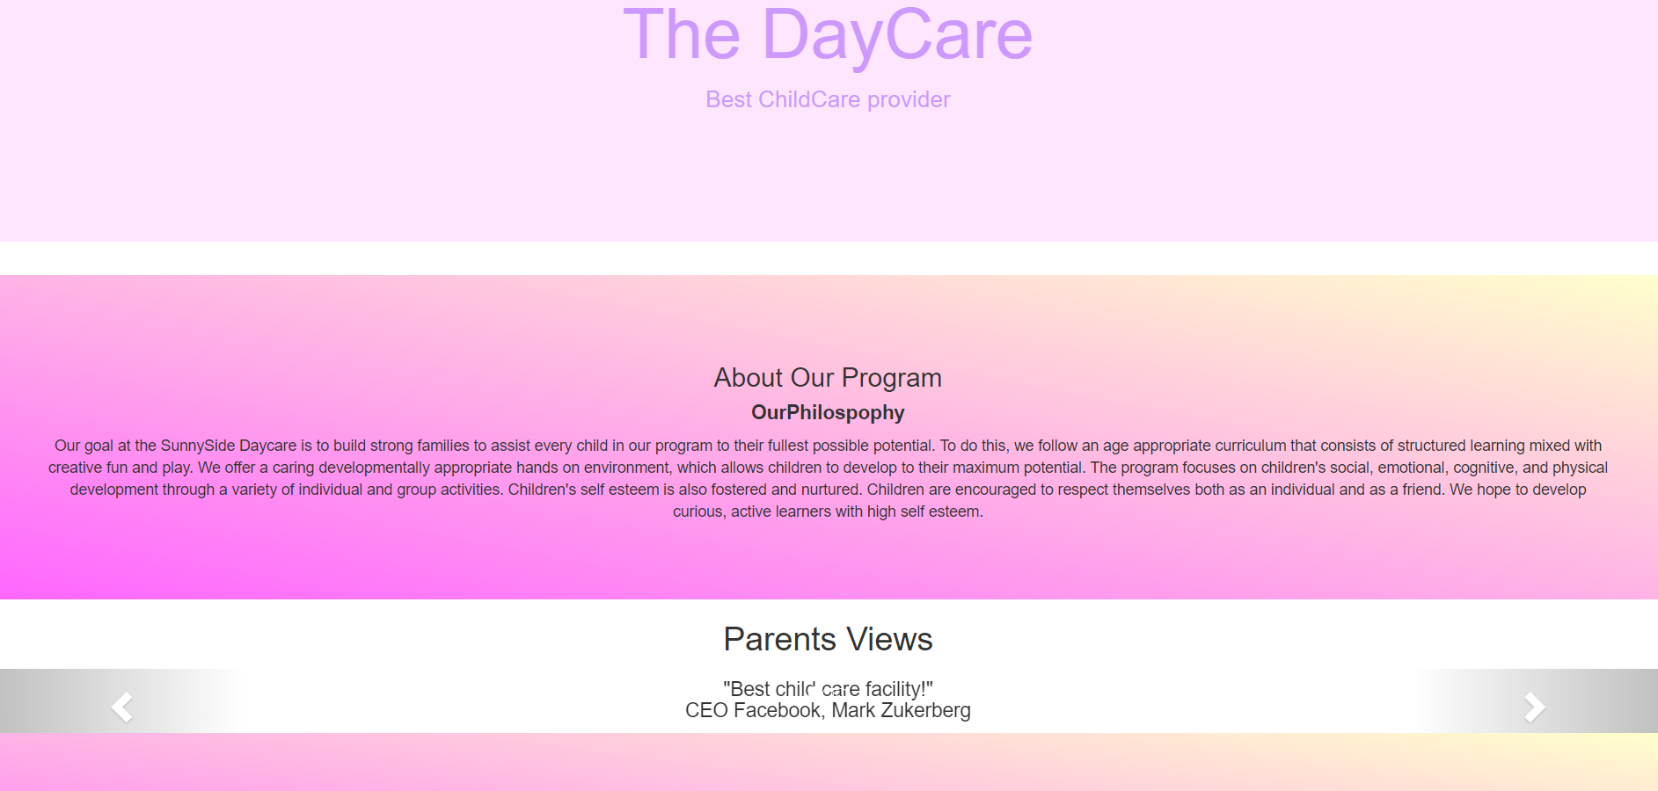

Login screen

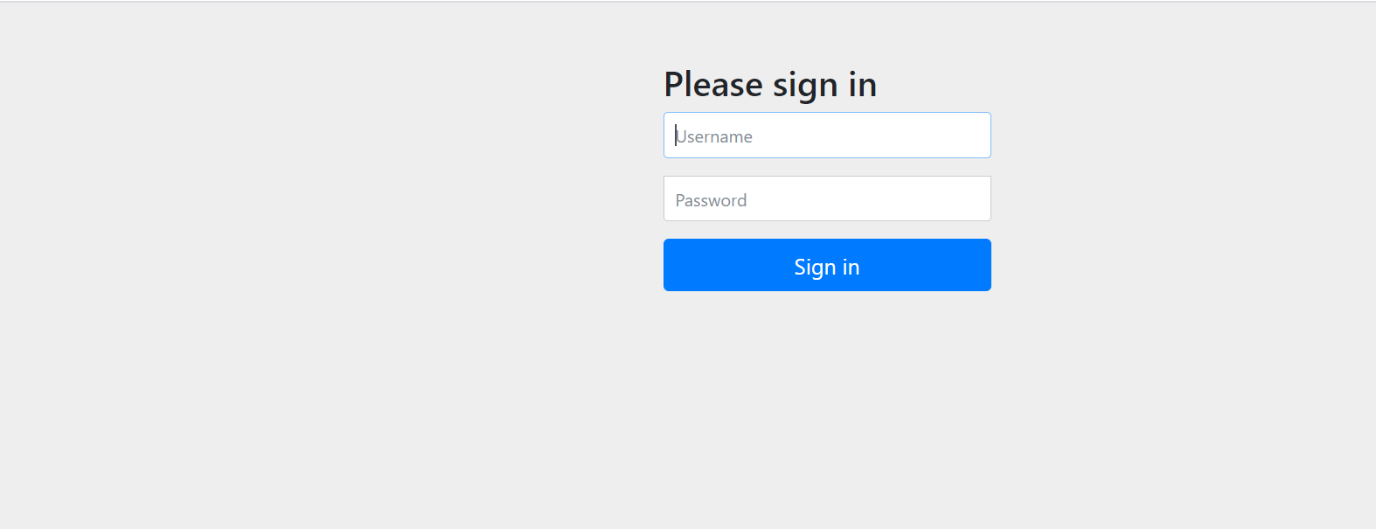

Logout Screen

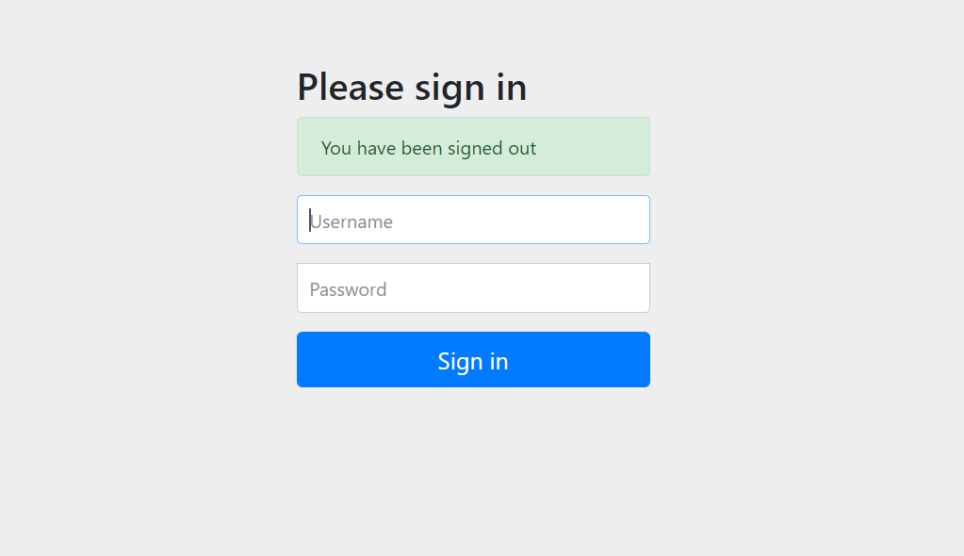

**Database**

Classroom Table

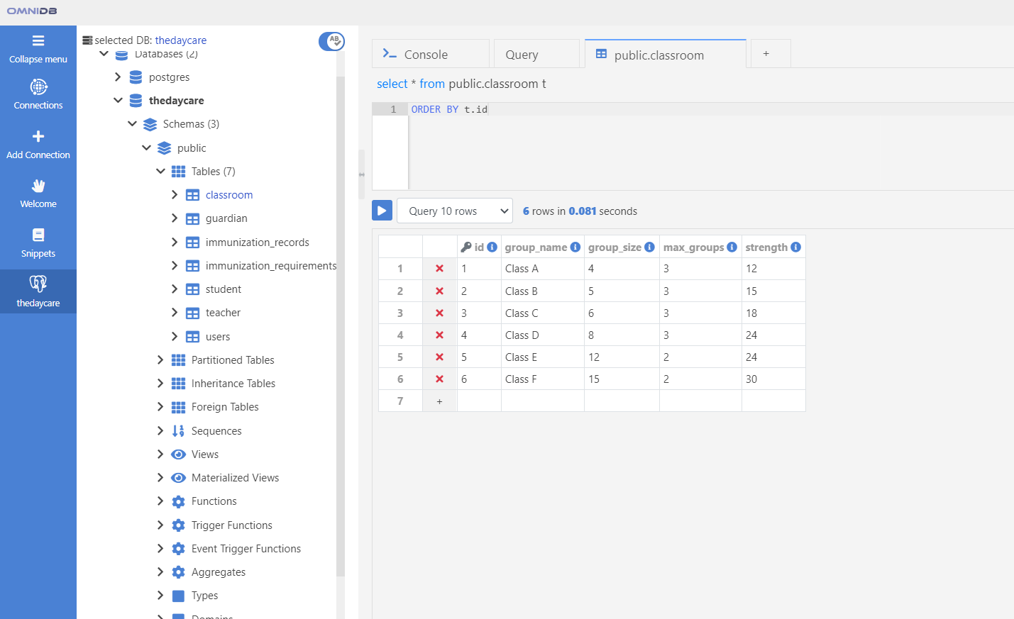

Guardian/Parent Table

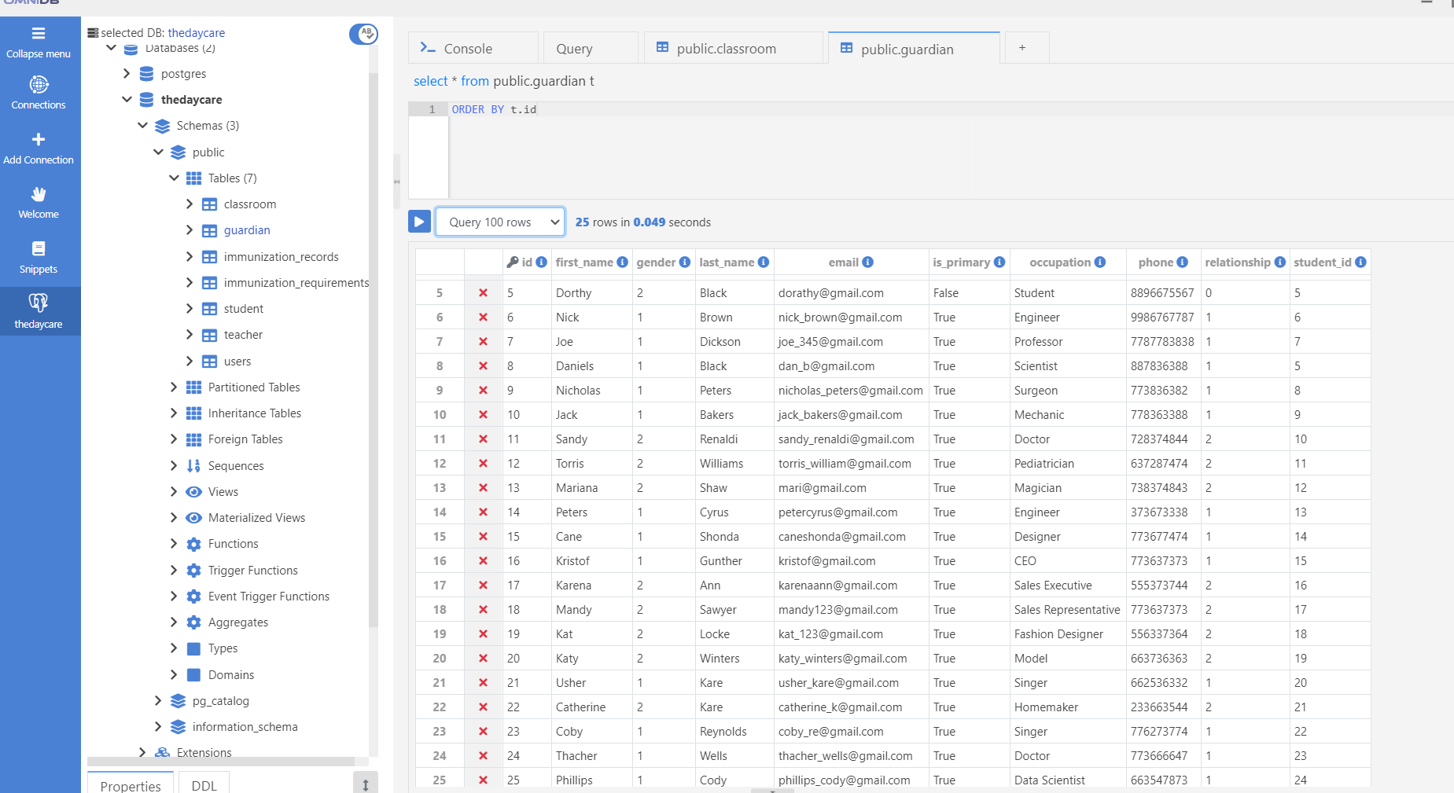

Student Table

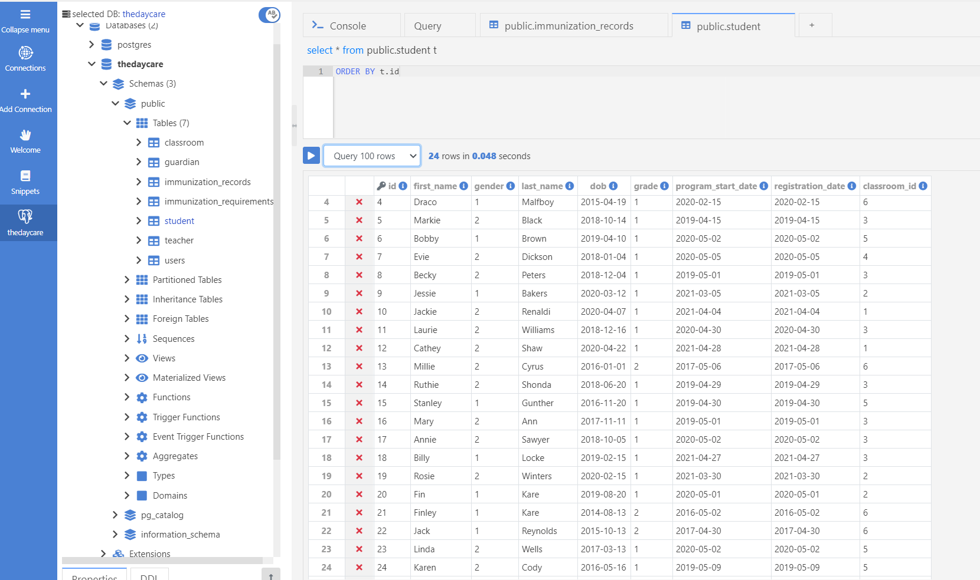

Teacher Table

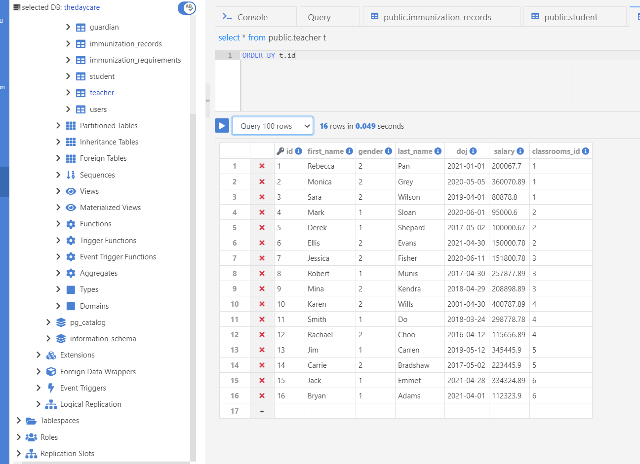

User table

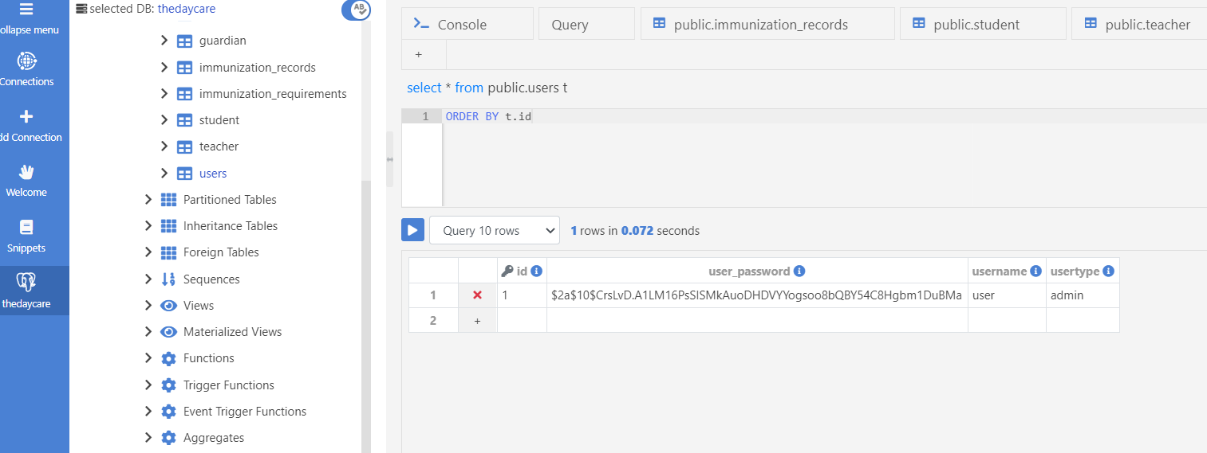

Immunization requirement Table

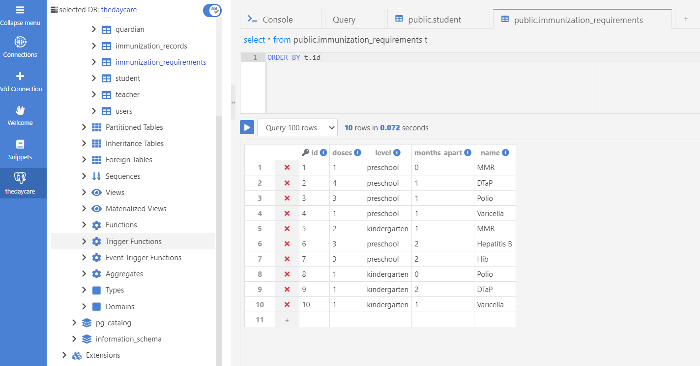

Immunization Record Table

